**Programming Exercise using Strings with Java**

**Part A. Using Strings and String methods.**

Modify the source code presented in class for searching String arrays,

1. Change the elements of the books[] array to have six of your favorite books as the array’s elements.
2. Change the parameters of the methods arrayname[i].endsWith, arrayname[i].startsWith, and arrayname[i].indexOf to reflect the titles of your books
3. Place your source code and a snapshot of your output below.

public class StringSearch {

public static void main (String[] args)

{

String[]books =

{"The Outsiders", "A Child Called It",

"Farenheit 451", "1984","Scary Stories",

"The Great Gatsby"};

int counter1 = 0, counter2 =0, counter3 = 0;

for(int i=0; i<books.length;i++)

{

System.out.print(books[i].substring(0,4) + "|");

//insert statement to count titles with certain ending

if(books[i].endsWith("It")) counter1++;

//insert statement to count titles with specific beginning

if(books[i].startsWith("The")) counter2++;

//insert statement to count titles found not containing specified substring

if(books[i].indexOf("Scary")==-1) counter3++;

}

//display search results

System.out.println("\nFound " + counter1 + " titles from this series It");

System.out.println("\nFound " + counter2 + " title with The");

System.out.println("\nFound " + counter3 + " other titles but not Scary");

}

}

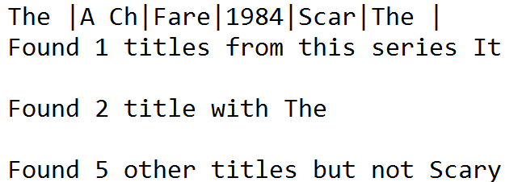

**Part B. Using the Stringbuilder Class (check out week 5 lecture notes part 2 for code hints and starter code below)**

Create a Java program that will…

1. Create a String array with the following elements: Lion, Tiger, Bear, Zebra, Elephant, Gorilla, Rhinoceros, then display the array
2. Append a new element: Hyena
3. Replace Gorilla with Chimpanzee, then display the modified array
4. Delete the element Zebra, then display the modified array
5. Sort the Array and then display the sorted array [

hint: use the Arrays.sort(arrayname) method.

Arrays.sort(Animals);

For (String Animal:Animals)

System.out.println("The sorted int array is:" + Animal));

1. Reverse the order of the array and then display the elements of the reverse array

Starter Code

//program to demo StringBuilder

**public** **class** ArrayAnimals

{

**public** **static** **void** main(String[] args)

{

StringBuilder sb = **new** StringBuilder();

String Animals[] = {"Lion","Tiger","Bear","Zebra" ,"Elephant","Gorilla","Rhinoceros"};

**for**(**int** i =0; i<Animals.length;i++)

sb.append(Animals[i]);

sb.append("Hyena");

System.***out***.println(sb);

//delete Zebra..Find start and end position of Zebra

sb.delete(13,18);

//display the String;

System.***out***.println(sb);

}

}

**Source Code:**

//program to demo StringBuilder

import java.util.Arrays;

//program to demo StringBuilder

public class ArrayAnimals

{

public static void main(String[] args)

{

StringBuilder sb = new StringBuilder();

String Animals[] = {"Lion","Tiger","Bear","Zebra" ,"Elephant","Chimpanzee","Rhinoceros"};

for(int i =0; i<Animals.length;i++)

sb.append(Animals[i]);

sb.append("Hyena");

System.out.println(sb);

//delete Zebra..Find start and end position of Zebra

sb.delete(13,18);

//display the String;

System.out.println(sb);

Arrays.sort(Animals);

for (String Animal:Animals)

System.out.println("The sorted int array is: " + Animal);

sb.reverse();

System.out.println("Reversed array is: ");

System.out.println(sb);

}

}

**Output:**

